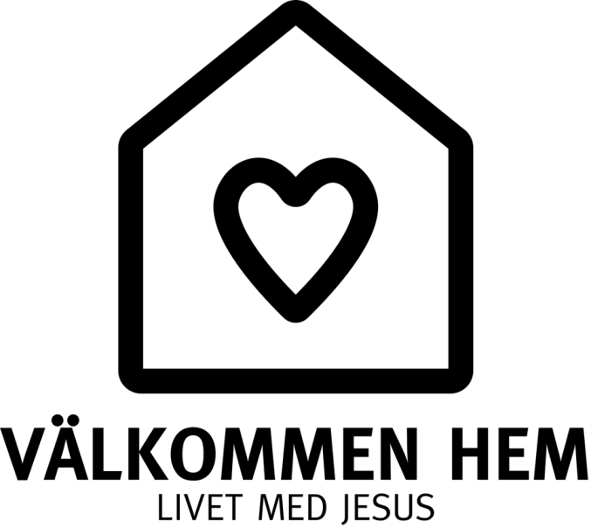

WELCOME HOME
LIFE WITH JESUS

The Salvation Army is a generous, open and growing community of people
of all ages and from all walks of life, with Jesus at the centre.

We will grow together as disciples,
sharing lives and deepening relationships with Jesus and others.

We will embrace the mission to make the world a better place.
We will proclaim salvation and offer a safe environment,
where people can experience restoration of body, soul and spirit.

vision 2025
Biblical background

”The Word became flesh and made his dwelling among us” (John 1:14, NIV)
Like God who comes to live among his own creation, we too want to live and be right where people are. In the midst of society, the eternal Word of God will become manifest; his will done through us. With Jesus as our example, we wish to draw nearer to one another, be welcoming and through our lives, contribute to the restoration of creation and humanity.
The parable of the prodigal son (Luke 15:11-32)
Jesus continued: "There was a man who had two sons.
The younger one said to his father, 'Father, give me my share of the estate.' So he divided his property between them." Not long after that, the younger son got together all he had, set off for a distant country and there squandered his wealth in wild living. After he had spent everything, there was a severe famine in that whole country, and he began to be in need. So he went and hired himself out to a citizen of that country, who sent him to his fields to feed pigs. He longed to fill his stomach with the pods that the pigs were eating, but no one gave him anything." When he came to his senses, he said, 'How many of my father's hired servants have food to spare, and here I am starving to death! I will set out and go back to my father and say to him: Father, I have sinned against heaven and against you. I am no longer worthy to be called your son; make me like one of your hired servants.' So he got up and went to his father. "But while he was still a long way off, his father saw him and was filled with compassion for him; he ran to his son, threw his arms around him and kissed him.
"The son said to him, 'Father, I have sinned against heaven and against you. I am no longer worthy to be called your son.' "But the father said to his servants, 'Quick! Bring the best robe and put it on him. Put a ring on his finger and sandals on his feet. Bring the fattened calf and kill it. Let's have a feast and celebrate.
For this son of mine was dead and is alive again; he was lost and is found.' So they began to celebrate.
"Meanwhile, the older son was in the field. When he came near the house, he heard music and dancing.
So he called one of the servants and asked him what was going on. 'Your brother has come,' he replied, 'and your father has killed the fattened calf because he has him back safe and sound.'" The older brother became angry and refused to go in. So his father went out and pleaded with him. But he answered his father, 'Look! All these years I've been slaving for you and never disobeyed your orders. Yet you never gave me even a young goat so I could celebrate with my friends. But when this son of yours who has squandered your property with prostitutes comes home, you kill the fattened calf for him!' 'My son,' the father said, 'you are always with me, and everything I have is yours. But we had to celebrate and be glad, because this brother of yours was dead and is alive again; he was lost and is found.' "
We believe that the eternal will of God is to gather all men and women to himself. Whether we are near or far away, the Father’s arms are open wide and he invites everyone to come home: to that home for which we are intended.
The believers gather (Acts 2:42 NIV)
They devoted themselves to the apostles’ teaching and to fellowship, to the breaking of bread and to prayer.
Home is life in community – in fellowship with the Lord, with those he has gathered and with those who are being gathered. It is a life that requires partnership and dedication; it is , a life that transcends cultural, ethnical, and economical barriers.
The feel/spirit of the theme ”Welcome Home”
Like a child coming home at night and being warmly embraced,
That’s what it was like for me when I came to God. I knew I had found my home.
I had a place in God’s great house, a place prepared just for me,
And I knew: I am finally home... I want to be a child in God’s home. (Göte Strandsjö)
We will transform
From being activity-based to building relationships
From offering programmes to living in community
From fostering passivity by offering services to encouraging involvement by offering partnerships.

Strategic Priorities:
- Every corps will prioritise the cultivation of a strong fellowship, and discipleship-training ahead of all other activities, in accordance with Acts 2:42 and Ephesians 4:11.13 (see the APEST*-image below).
- Every social centre will offer fellowship and create a welcoming, homely atmosphere. In partnership with nearby corps, will develop a plan for how the people we meet can be offered inclusion and a sense of belong in the fellowship of the corps.
- Every corps will identify, develop and provide opportunities for local lay leaders to function, and every corps will build a leadership-team based on the APEST model.
- We will encourage volunteering in corps and social centres
- We will prioritise reaching out and presenting Jesus to
  - children, youth and young adults
  - the marginalised and those .
We aim to make them active in the fellowship of the corps and in the mission of the Salvation Army.
- Using contemporary systems and communication methods that are relevant to younger generations, we will develop spaces and adjust our halls to promote fellowship and create a sense of home.
- Every local corps and centre will take financial responsibility for its operations.

* APEST – Apostle, Prophet, Evangelist, Shepherd & Teacher, the five gifts of the spirit presented in Ephesians 4.11-13
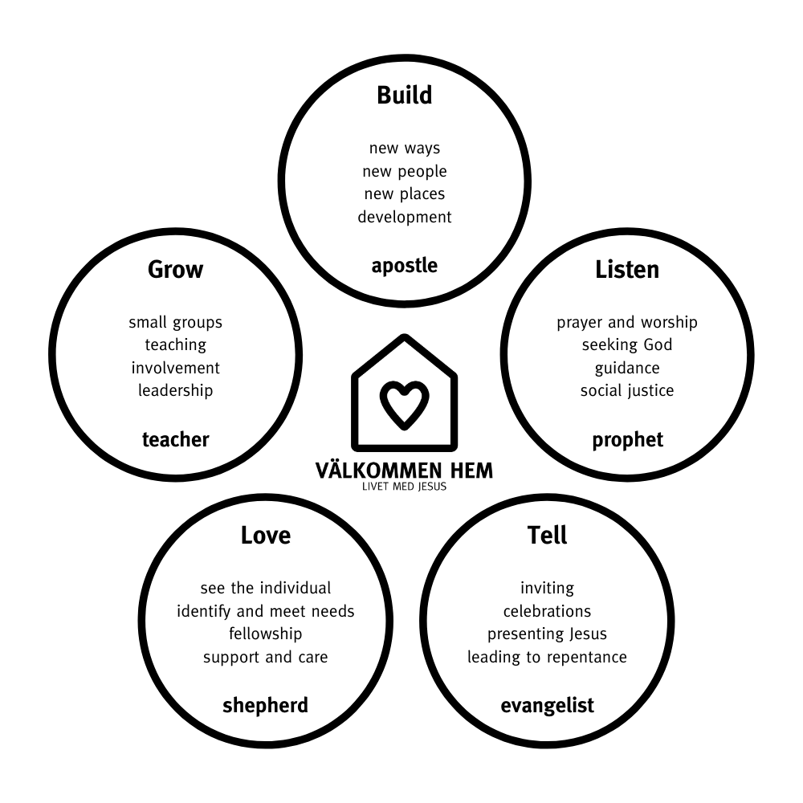

What this means for the leadership of The Salvation Army, on territorial and divisional level.

- Helpful and supportive attitude towards those cops/centres that intentionally work in accordance with the strategic priorities. ”How can we help you succeed?”
HQ/DC will have a greater focus on alignment to the strategic priorities than of anything else.

- Consistency in prioritising (finances, personnel, support) to corps/centres that work in accordance with the strategic priorities.
HQ/DC will give time and focus to the corps/centres/co-workers where there is a potential for success. We will water where it grows.

- Teaching, communication, resources and material from territorial and divisional will be consistent in supporting the strategic priorities.
Continued development of social media as well as the use of audio and video.

- Prioritising of flexible and alternative mission initiatives as well as the restart or new plants of corps and centres.
Resources are made available, for example when unproductive corps/centres are terminated, according to John 15:2.

- Focus on the concept, ”member”. All who believe in Jesus, wish to follow him and affirm the mission and doctrinal statements of The Salvation Army are welcome if they wish to be members of The Salvation Army.
Soldiership is presented as an attractive way for members to commit and dedicate their whole lives and lifestyle at a deeper level in service to God.

- Evaluate/reassess the need for property and buildings.
Focus on relationships will affect the way we think about buildings. Relevance must precede tradition.

